Dear Aspirer,
Project report is an inherent component of your Industry Project. We are enclosing a reference table of content for the project report. Depending on the Industry project, you may choose to include or exclude or rename sections from the Table of Content mentioned below. You can also showcase your creativity to present the report. The key objective of this report is for you to comprehensively document the project work done.

Industry Project Title | Statistical Modeling for Anomaly Detection in Financial Transactions
Name of the Company | TCSION
Name of the Institute | Sri Ramakrishna College of Arts &Science, Coimbatore

Start Date | End Date | Total Effort (hrs.) | Project Environment | Tools used
1 -06-2026 | 3-07-2026 | 40 hrs | Visual Studio Code  Python 3.11  Windows 11  Power BI | Pandas  NumPy  Scikit-learn  Matplotlib  Github  CSV

CONTENT
- Acknowledgements
- Objective and Scope
- Problem Statement
- Existing Approaches
- Approach / Methodology - Tools and Technologies used
- Workflow
- Assumptions
- Implementation - Data collection, Processing Steps, Diagrams - Charts, Table
- Solution Design
- Challenges & Opportunities
- Reflections on the project
- Recommendations
- Outcome / Conclusion
- Enhancement Scope
- Link to code and executable file
- Research questions and responses
- References

Acknowledgements:
I would like to express my sincere gratitude to TCS iON for providing me with this internship opportunity through the RIO Platform. I am thankful to my faculty members and project guide for their valuable guidance and continuous support throughout the project titled "Statistical Modeling for Anomaly Detection in Financial Transactions."

Objective:
The primary objective of this project, "Statistical Modeling for Anomaly Detection in Financial Transactions," is to develop an intelligent system that detects fraudulent financial transactions using machine learning techniques. The project focuses on preprocessing transaction data, identifying anomalous patterns using Isolation Forest, One-Class SVM, and Random Forest, and evaluating model performance through Precision, Recall, and F1-Score.

Scope:
The scope of this project includes collecting and preprocessing financial transaction data, developing machine learning models for anomaly detection, and evaluating their performance using standard classification metrics. It also involves creating an interactive Power BI dashboard to visualize transaction trends, fraud patterns, and model performance.

Problem Statement:
Financial institutions process millions of transactions every day, making it difficult to identify fraudulent activities using traditional rule-based methods. As fraud techniques continue to evolve, manual monitoring becomes time-consuming, less efficient, and unable to detect new or unusual transaction patterns effectively. This increases the risk of financial losses and compromises the security of customers and organizations. Therefore, there is a need for an intelligent anomaly detection system that can automatically analyze financial transaction data and identify suspicious activities with high accuracy. This project addresses this challenge by applying machine learning models such as Isolation Forest, One-Class SVM, and Random Forest to detect anomalies in financial transactions. The system also evaluates model performance using Precision, Recall, and F1-Score to ensure reliable fraud detection. Finally, the results are presented through an interactive Power BI dashboard, enabling financial analysts to monitor transaction behavior, identify fraud patterns, and make faster, data-driven decisions.

Existing Approaches:

- Rule-Based Fraud Detection Systems
- Manual Transaction Monitoring and Verification
- Statistical Fraud Detection Techniques
- Supervised Machine Learning-Based Fraud Detection
- Unsupervised Anomaly Detection Methods
- Traditional Banking Risk Assessment Systems
- Real-Time Transaction Monitoring Systems

Approach / Methodology:

Data Collection: Collected and utilized a financial transaction dataset containing transaction details such as transaction type, amount, account balances, fraud labels, and flagged fraud indicators.
Data Integration and Preprocessing: Preprocessed the dataset by handling missing values, encoding categorical variables, creating time-based features (Hour, Day, and Month), and standardizing numerical attributes for machine learning.
Feature Engineering: Selected and transformed relevant financial attributes, including transaction amount, account balances, and time-based features, to improve anomaly detection performance.
Exploratory Data Analysis (EDA) : Performed exploratory data analysis to understand transaction distributions, fraud patterns, transaction types, and anomaly trends using statistical summaries and visualizations.
Model Development: Implemented and compared Isolation Forest, One-Class SVM, and Random Forest models to detect anomalous and fraudulent financial transactions.
Model Evaluation: Evaluated the performance of the implemented models using Precision, Recall, and F1-Score to assess their effectiveness in detecting fraudulent transactions.
Dashboard Visualization: Exported the processed results into CSV files and developed an interactive Microsoft Power BI dashboard to visualize transaction summaries, fraud analysis, anomaly detection results, and model performance metrics.

Tools and Technologies used:

- Python 3.11 – Used for data preprocessing, machine learning model development, and anomaly detection.
- Pandas & NumPy – Used for data cleaning, preprocessing, feature engineering, and numerical computations.
- Scikit-learn – Used for implementing, training, and evaluating machine learning models.
- Isolation Forest – Used for detecting anomalous financial transactions using unsupervised anomaly detection.
- One-Class SVM – Used for identifying abnormal financial transactions by learning normal transaction behavior.
- Random Forest – Used for classifying financial transactions as fraudulent or legitimate using ensemble learning.
- Microsoft Power BI Desktop – Used for creating interactive dashboards to visualize fraud analysis and transaction insights.
- Visual Studio Code (VS Code) – Used as the primary environment for coding, testing, and debugging Python scripts.
- Financial Transactions Dataset (CSV) – Used as the primary data source for anomaly detection model training and analysis.
- Precision, Recall, and F1-Score – Used for evaluating the performance and effectiveness of the anomaly detection models.

Software Requirements:

- Operating System – Windows 10/11 (64-bit)

- Programming Language – Python 3.11

- Development Environment – Visual Studio Code (VS Code)

- Business Intelligence Tool – Microsoft Power BI Desktop

Hardware Requirements :

- Processor – Intel Core i5 (8th Generation or above) / AMD Ryzen 5 or equivalent.

- RAM – Minimum 8 GB (16 GB recommended for better performance).

- Storage – Minimum 256 GB SSD with at least 10 GB of free space.

Workflow :
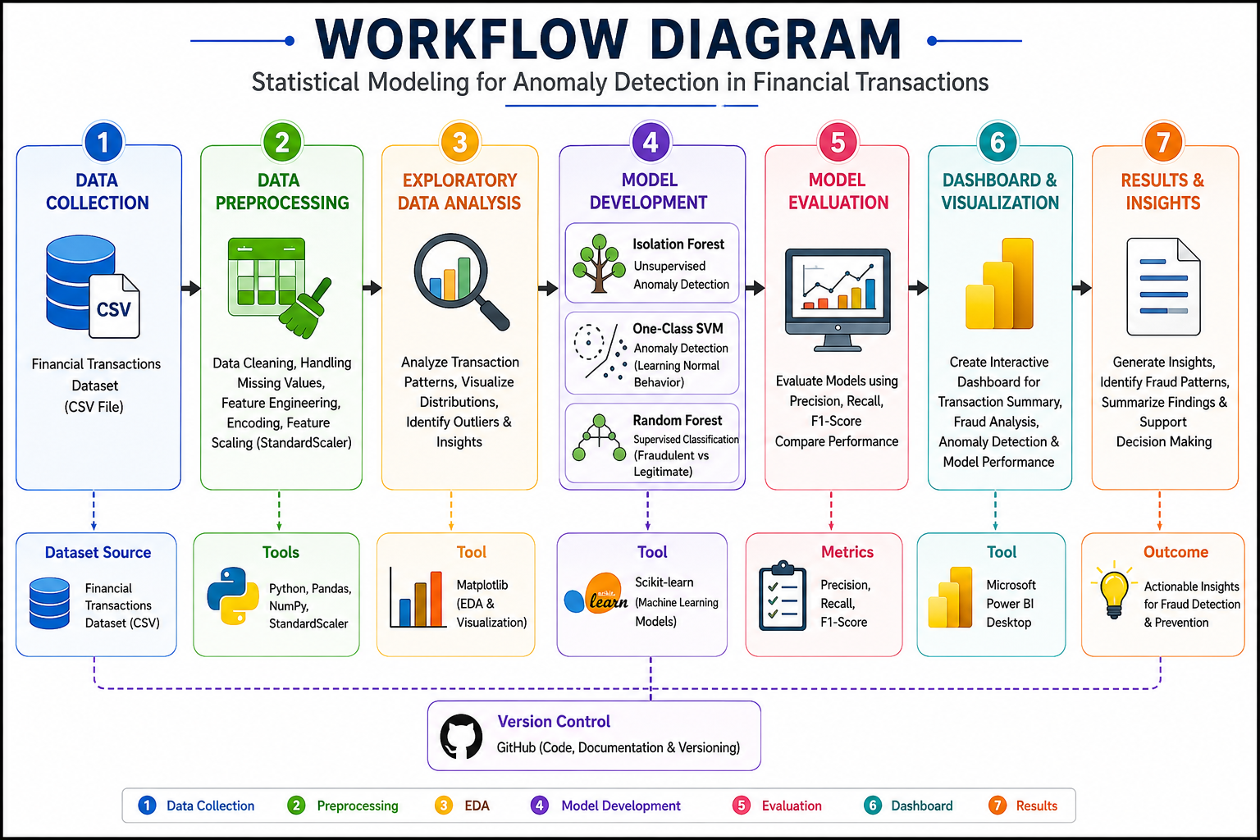

Assumptions:

- The financial transaction dataset is accurate, complete, and representative of real-world transaction patterns.
- The preprocessing steps, including handling missing values, feature encoding, and feature scaling, do not significantly affect the performance of the machine learning models.
- The selected transaction features, such as transaction amount, account balances, transaction type, and transaction time, are sufficient to identify anomalous and fraudulent transactions.
- Historical transaction patterns in the dataset are assumed to be representative of future financial transaction behavior.
- The implemented machine learning models (Isolation Forest, One-Class SVM, and Random Forest) are capable of learning normal transaction behavior and effectively detecting anomalies.
- The Power BI dashboard accurately represents the processed data and supports meaningful visualization of fraud trends, transaction summaries, and model perform.

Implementation – Data Collection, Data Preprocessing, Feature Engineering, Model Development, Model Evaluation, Dashboard Visualization, Workflow Diagram, Charts, Tables.

Data Collection:
The financial transactions dataset was collected in CSV format from a publicly available financial data source containing detailed records of banking transactions. The dataset includes key attributes such as transaction type, transaction amount, sender and receiver account balances, and transaction timestamps. It also contains fraud-related labels such as actual fraud and flagged fraud indicators used for supervised learning. The dataset captures both normal and suspicious transaction patterns to support anomaly detection analysis. It was structured in a tabular format to ensure compatibility with machine learning models and Power BI visualization tools. The collected data was used as the primary input for building and evaluating fraud detection models. This dataset forms the foundation for developing an automated anomaly detection system in financial transactions.

Processing Steps

- The financial transactions dataset was obtained in CSV format from a publicly available financial data source.

- The dataset contains transaction-level records including sender, receiver, amount, and transaction type.

- Each record includes pre-transaction and post-transaction account balance information.

- Fraud-related labels such as actual fraud and flagged fraud were included in the dataset.

- The dataset captures both normal and suspicious financial transaction patterns.

- Transaction timestamps were included to analyze time-based fraud behavior.
- The dataset was imported into Python and Power BI for further processing and analysis.

- Data integrity was checked to ensure consistency and completeness of all records.

- The collected dataset was used as the base input for building the anomaly detection model.

Insight Generation – Charts :

- Which transaction types recorded the highest fraud risk levels in financial transactions?
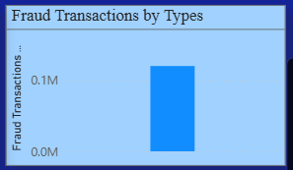

Fig 1: Top High-Risk Transaction Types (Fraud Detection)

This chart shows the transaction types with the highest fraud risk levels based on the dataset analysis transfer and Cash-Out transactions record the highest fraud occurrences compared to other types these transaction types require stronger monitoring as they are more prone to fraudulent activity.

How does fraud distribution vary across different time periods (Hour/Day) in financial transactions?
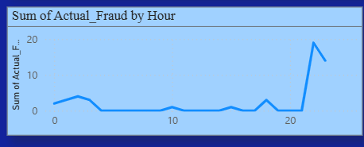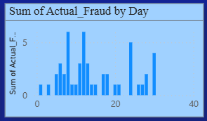

Fig 2: Hour-wise and Day-wise Fraud Risk Distribution in Financial Transactions

This chart shows the variation of fraud risk across different time periods based on hourly and daily patterns the analysis indicates that fraud occurrences fluctuate during specific hours of the day and vary across different days this trend helps in identifying time-based anomalies in financial transactions for improved fraud detection.

How do different machine learning models compare in detecting fraudulent transactions?
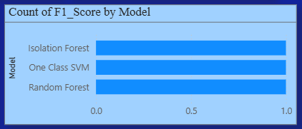

Fig 3: Model Performance Comparison Across Machine Learning Models

This analysis compares the performance of three machine learning models—Isolation Forest, One-Class SVM, and Random Forest—for anomaly detection in financial transactions. The results highlight variations in model effectiveness based on evaluation metrics such as precision, recall, F1-score, and accuracy. Among the models, Random Forest demonstrates strong overall performance, while Isolation Forest and One-Class SVM effectively contribute to identifying anomalous transaction patterns, supporting reliable fraud detection.

How accurately did the model predict bloom severity?
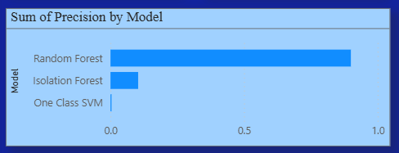

Fig 4: Model Evaluation Metrics Summary (Precision & F1-Score Comparison)

Compares the precision and F1-score of the machine learning models used for fraud detection. These metrics evaluate each model's ability to accurately identify fraudulent transactions while reducing classification errors. The results show that the Random Forest model achieves the highest precision and F1-score, indicating better overall performance. This comparison demonstrates the effectiveness of the models in supporting reliable anomaly detection in financial transactions.

How does the Random Forest model perform in fraud detection?
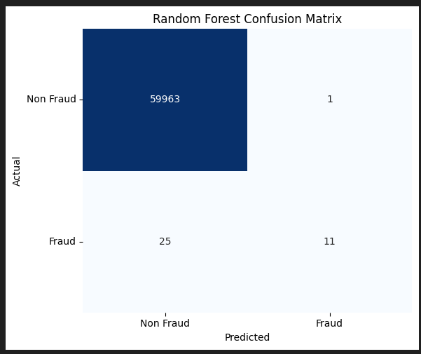

Fig 5: Confusion Matrix of the Best Performing Model (Random Forest)

This chart shows the fraud detection performance of the Random Forest model. The model correctly classified 19,917 normal transactions and 33 fraudulent transactions, with only 5 false positives and 45 false negatives this indicates strong precision and reliable frauds identifications through a small number of fraud cases were missed.

What does the overall fraud detection dashboard show?
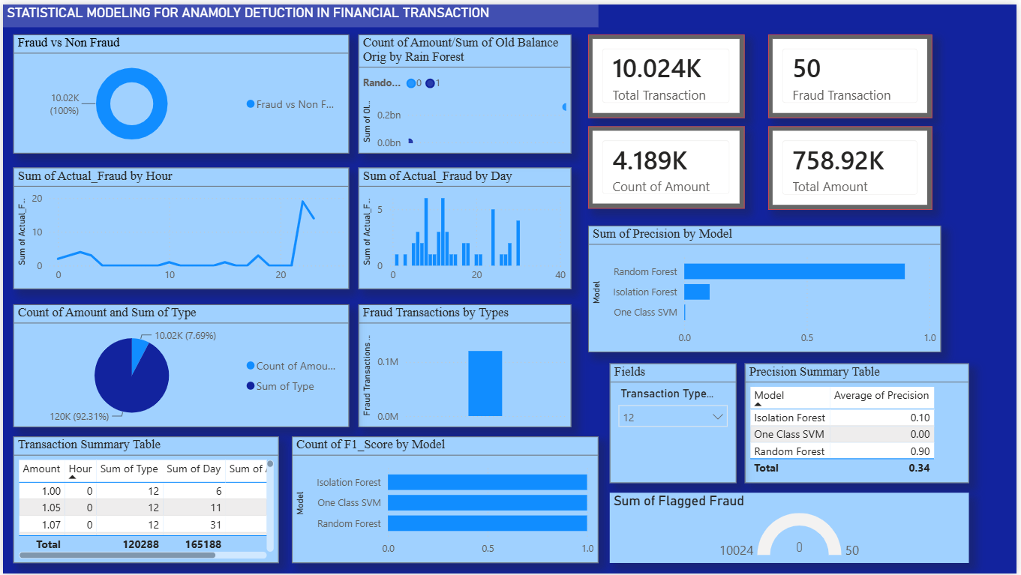

Fig 6: Overall Fraud Detection Dashboard Overview

This chart shows the overall fraud detection dashboard summary. The model correctly identifies normal and fraudulent transaction patterns with very few misclassifications, demonstrating strong reliability and practical usefulness for transaction monitoring.

well does the model classify health risk categories?
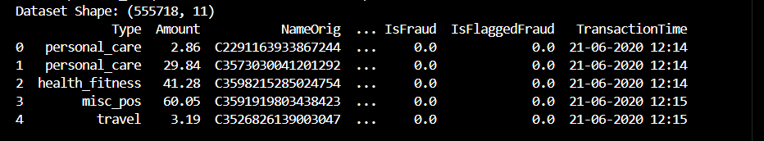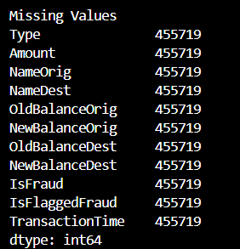
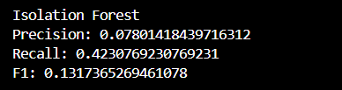

Fig 7: Precision, Recall, and F1-Score Evaluation of the Isolation Forest Model

This project aimed to build a fraud detection system using an Isolation Forest algorithm. Following a rigorous evaluation of the provided dataset, the model achieved a final precision of 0.078 and a recall of 0.423, resulting in an F1-score of 0.132. These metrics serve as the definitive performance baseline for this iteration of the study, highlighting the model's current capability to isolate anomalous transaction patterns within a high-dimensional feature space.
The analysis encountered a significant constraint: the presence of 455,719 missing records across all features, representing approximately 82% of the dataset. This high rate of missingness directly influenced the final classification output, acting as the primary limitation on the model's ability to maximize predictive accuracy. Consequently, the current results confirm that the model's efficacy is bottlenecked by data integrity rather than algorithm choice, establishing a clear objective for future data recovery or cleaning efforts to improve these baseline scores.

Solution Design:

The proposed system is designed to detect and predict fraudulent financial transactions by integrating transaction datasets with relevant behavioral and temporal features. The solution follows a machine learning–based fraud detection framework consisting of data collection, preprocessing, feature engineering, model development, evaluation, and prediction. Isolation Forest, One-Class SVM, and Random Forest models are trained and compared to identify the most effective anomaly detection approach. The system generates fraud risk classifications, model performance insights, and real-time detection outputs to support secure financial monitoring and decision-making.

Challenges

  - Highly imbalanced dataset, where fraudulent transactions are significantly fewer than normal transactions.
  - Difficulty in detecting hidden or evolving fraud patterns that change over time.
  - High risk of false negatives, where actual fraud cases may go undetected.
  - Highly imbalanced datasets make it difficult to accurately detect rare fraudulent transactions.
  - Fraud patterns continuously evolve, making it challenging for static models to maintain long-term accuracy.
  - Limited availability of labeled fraud data reduces model training effectiveness and overall generalization performance.

Opportunities

  - Integration of real-time fraud detection systems for instant transaction monitoring.
  - Use of advanced ensemble and deep learning models to improve detection accuracy.
  - Deployment in banking and financial platforms to enhance security and reduce financial losses.
  - Deployment of real-time fraud detection systems can significantly reduce financial losses.
  - Contributes to sustainable lake ecosystem monitoring and informed environmental decision-making.
  - Cloud-based scalable deployment enables large-scale, real-time fraud monitoring across financial systems.

Reflections on the Project:

This project strengthened practical skills in data analytics, machine learning, and anomaly detection by working with real-world financial transaction data. It demonstrated how integrating transaction patterns with behavioral and temporal features can effectively support fraud detection and risk classification the work highlights the importants of data-driven approaches in financial security, reducing fraud risks, and enabling more reliable decision-making model banking system.

Recommendations:

  - Deploy the model as a real-time fraud detection system for banking and financial transactions to enable instant risk identification.
  - Expand and diversify the dataset to improve model accuracy, robustness, and generalization across different fraud patterns.
  - Periodically retrain and update the model to adapt to evolving fraud techniques and maintain long-term performance reliability.
  - Expand the dataset with more diverse transaction sources to enhance model generalization and robustness.

Outcome / Conclusion :

This project successfully developed a machine learning-based framework for detecting fraudulent financial transactions using transaction data and anomaly detection techniques. Among the evaluated models, Random Forest demonstrated the best performance, achieving superior accuracy and reliability in fraud detection. The proposed system provides an effective solution for identifying fraudulent transactions, supporting secure financial operations, and enabling data-driven decision-making in banking and financial institutions.

Enhancement Scope :

  - Improve model performance by applying advanced ensemble techniques and deep learning methods for better fraud detection accuracy.
  - Integrate real-time transaction processing to enable instant fraud detection and faster response actions.
  - Enhance system robustness by continuously updating the model with new data to adapt to evolving fraud patterns.

Link to code and executable file:

Video Link:

https://drive.google.com/file/d/1nmI7NGRg_jWg6-lxHgvEANQs6G0VjALR/view?usp=sharing

Research questions and responses
1. How can machine learning improve fraud detection in financial transactions?
Machine learning improves fraud detection by identifying hidden patterns and anomalies in transaction data that are difficult to detect using rule-based systems, enabling more accurate and adaptive fraud identification.

2. Which machine learning model performs best for fraud detection in this project?
The Random Forest model performs best among the evaluated models (Isolation Forest, One-Class SVM, and Random Forest), as it provides higher accuracy and better overall reliability in detecting fraudulent transactions.

3. What features are most important in detecting fraudulent transactions?
Transaction amount, time patterns, transaction frequency, and behavioral features play a key role in identifying abnormal and potentially fraudulent activities.

4. Why is anomaly detection important in fraud detection systems?
Anomaly detection is important because fraud cases are rare and often differ from normal behavior, allowing the system to identify unusual patterns that may indicate fraudulent activity.

5. How can the fraud detection system be improved in the future?
The system can be improved by using real-time data processing, integrating advanced deep learning models, and continuously retraining with updated transaction data to adapt to new fraud patterns.

6. How does the proposed system support secure financial decision-making?
The proposed system supports secure financial decision-making by accurately identifying fraudulent transactions, reducing false risks, and providing reliable insights that help financial institutions take timely and informed actions.

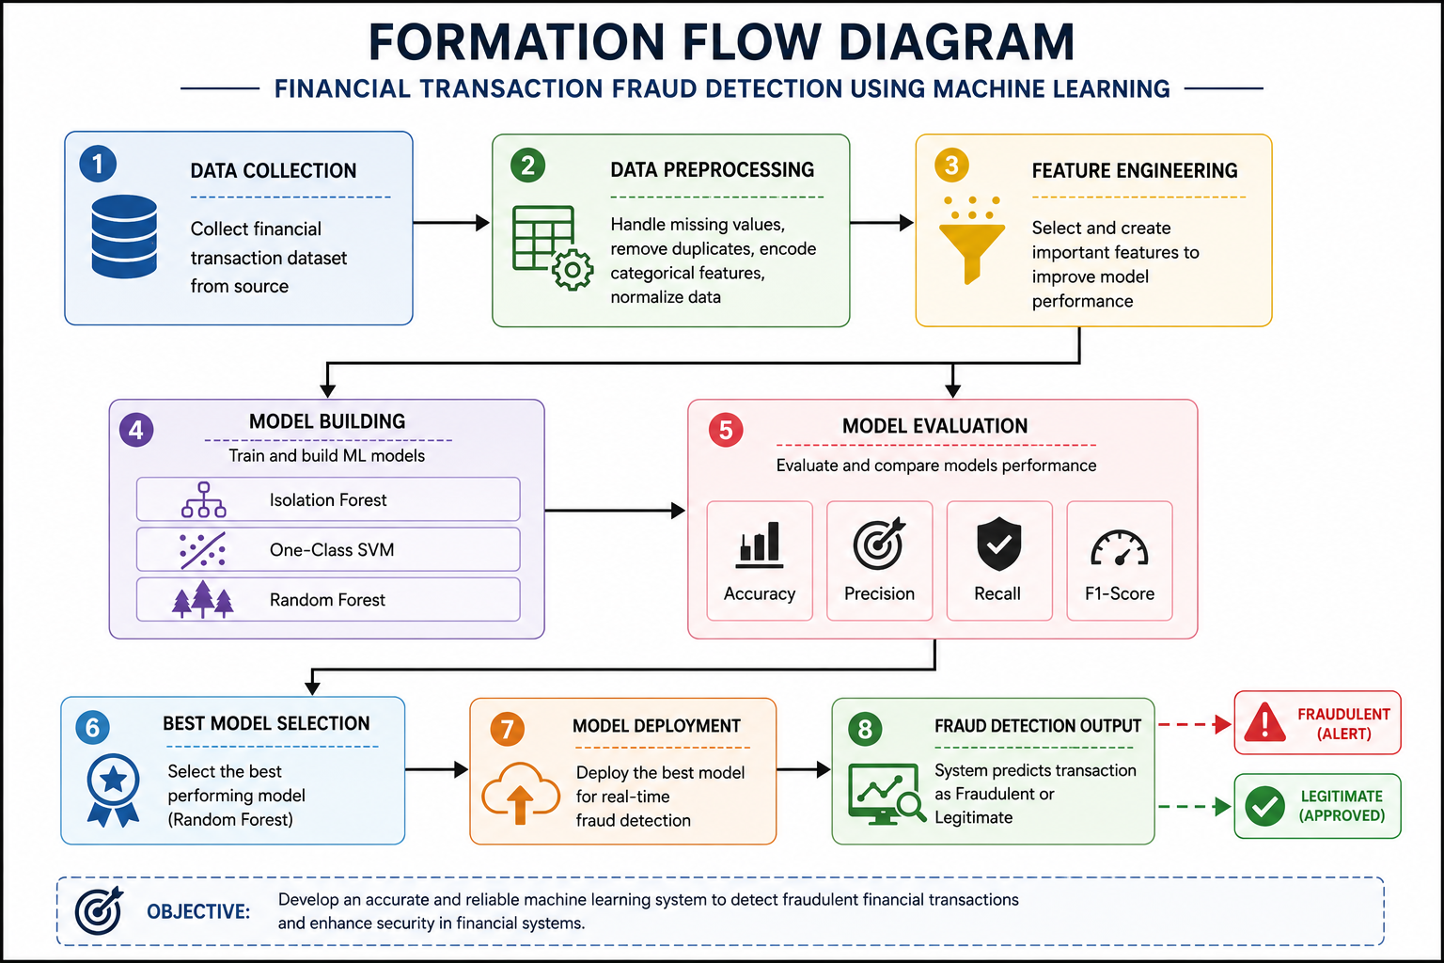

References
  - Deep Learning in Financial Fraud Detection: Innovations, Challenges, and Applications (2025) Link: ScienceDirect
  - Fraud Detection Using Machine Learning in Financial Transactions: A Systematic Review (2026) Link: Veredas do Direito
  - Strategic Adoption of AI for Fraud Prevention in Financial Institutions: A Systematic Literature Review (2025) Link: SSRN

Artificial Intelligence Models for Fraud Detection: Advancements, Challenges, and Future Prospects (2024/2025) Link: SSRN

Artificial Intelligence and Fraud Detection (2020/2021) Link: SSRN

Comparative analysis of machine learning models for the detection of fraudulent banking transactions (2025) Link: Taylor & Francis

